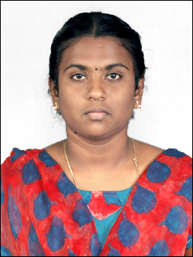Name : M.Kasthuriselvi

Qualification : M.Sc Computer Science

Address : D/o A.Muthuramalingam,

10/99D,SanguMuthuammalPuram,

RamayanPatti,

Tirunelveli-627358.

Job Role : Programmer.

Company Details : Sathi Systems Private Limited,

GPR Building,3rd Floor,

19-Pioneer Kumarasamy Nagar,

New Bus Stand TO STC Road,

Tirunelveli-627007.

Name : E.Revathi

Qualification : M.Sc Computer Science

Address :

Job Role : Programmer.

Company Details : Sathi Systems Private Limited,

GPR Building,3rd Floor,

19-Pioneer Kumarasamy Nagar,

New Bus Stand TO STC Road,

Tirunelveli-627007.

Name : M.Mohamed Basith

Qualification : M.Sc Computer Science

Address :

Job Role : Programmer.

Company Details : Sathi Systems Private Limited,

GPR Building,3rd Floor,

19-Pioneer Kumarasamy Nagar,

New Bus Stand TO STC Road,

Tirunelveli-627007.